
FACULTY OF TECHNOLOGY AND ENGINEERING
DEVANG PATEL INSTITUTE OF ADVANCE TECHNOLOGY
AND RESEARCH

DEPARTMENT OF COMPUTER ENGINEERING

A.Y 2026 – 27 Semester – 3

LAB MANUAL

CSUC201 Fundamentals of Data Structures and Algorithms

Practical 8: Binary Tree Traversals and Binary Search Tree
Insertion
Practical Aim
To implement binary tree traversals and binary search tree insertion, and develop the ability to
reason about how the order of visiting nodes changes the information retrieved from a tree.
Problem 1
A company stores its organizational hierarchy as a tree — the CEO at the top, managers below,
and employees at the leaves. Different departments need the hierarchy printed in different
orders: HR wants each manager printed between their left and right sub-teams, the archive
department wants each manager printed before their sub-teams, the payroll department wants
each manager printed after all their sub-teams are listed, and the floor manager wants everyone
printed level by level from top to bottom. Given a binary tree representing the hierarchy,
implement all four printing orders and display the result of each.
For Code:
#include <iostream>
#include <queue>
using namespace std;

struct Node
{
int data;
Node* left;
Node* right;
};

Node* createNode(int value)
{
Node* newNode = new Node();

newNode->data = value;
newNode->left = NULL;
newNode->right = NULL;

return newNode;
}

void preorder(Node* root)
{
if(root == NULL)
return;

cout << root->data << " ";
preorder(root->left);
preorder(root->right);
}

void inorder(Node* root)
{
if(root == NULL)
return;

inorder(root->left);
cout << root->data << " ";
inorder(root->right);
}

void postorder(Node* root)
{
if(root == NULL)
return;

postorder(root->left);
postorder(root->right);
cout << root->data << " ";
}

void levelOrder(Node* root)
{
if(root == NULL)
return;

queue<Node*> q;

q.push(root);

while(!q.empty())
{
Node* temp = q.front();
q.pop();

cout << temp->data << " ";

if(temp->left != NULL)
q.push(temp->left);

if(temp->right != NULL)
q.push(temp->right);
}
}

int main()
{
Node* root = createNode(1);

root->left = createNode(2);
root->right = createNode(3);

root->left->left = createNode(4);
root->left->right = createNode(5);

root->right->left = createNode(6);
root->right->right = createNode(7);

cout << "Preorder: ";
preorder(root);

cout << "\nInorder: ";
inorder(root);

cout << "\nPostorder: ";
postorder(root);

cout << "\nLevel Order: ";
levelOrder(root);

return 0;
}
Output:
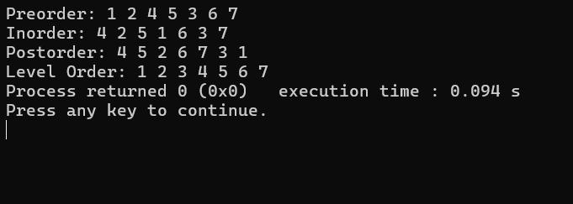

Problem 2
A school library uses a system where every book is assigned a unique code when it arrives.
Books are organized so that at any shelf position, all books to the left have smaller codes and
all books to the right have larger codes. This arrangement lets staff find any book quickly by
always knowing which direction to look. Given a sequence of book codes arriving one by one,
insert each into the correct position and print the inorder sequence after all insertions are
complete.
For Code:
Output:
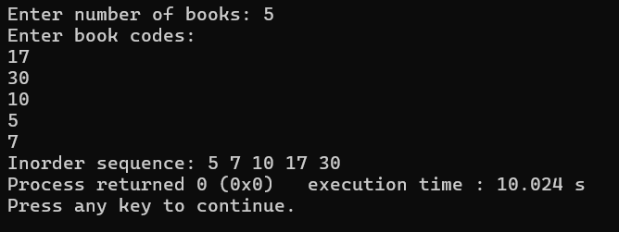
Outcome/Conclusion:
These two practicals helped in understanding binary tree traversals and binary search tree insertion. We learned how different traversal methods visit nodes in different orders and how a BST organizes data for efficient searching.

Key Questions / Analysis / Interpretation to be Evaluated During/After Implementation
- [Problem 1] A circular array is one way to reuse freed slots without shifting all elements.
Without implementing it, explain what change would need to be made to your front and
rear pointer logic to make the array behave circularly, and what new condition would
indicate a full array.
Ans:- The front and rear pointers should wrap around to the beginning when they reach the end of the array, using modulo logic. The array is full when (rear + 1) % size == front.

- [Problem 2] Your linked list stack has no fixed capacity limit. But in practice, can it still
run out of space? What determines the actual limit, and why is that limit invisible in your
code?
Ans:- Yes, a linked list stack can still run out of space. Its limit depends on the available system memory (heap). This limit is not fixed in the code because nodes are created dynamically until memory is exhausted.

- [Problem 3] operator precedence determines the order in which operators are placed
into the output. Without tracing any expression, explain what would go wrong in your
output if your solution treated all operators as having equal precedence.
Ans:- If all operators have equal precedence, operators would be processed in the wrong order. For example, multiplication might not be performed before addition, resulting in an incorrect postfix expression and wrong final result.

